**DAILY ONLINE ACTIVITIES SUMMARY**

|  |  |  |  |  |  |  |  |  |
| --- | --- | --- | --- | --- | --- | --- | --- | --- |
| **Date:** | **10-06-2020** | | | | | **Name:** | **Huda Sultana** | |
| **Sem & Sec** | **8 A** | | | | | **USN:** | **4AL16CS039** | |
| **Online Test Summary** | | | | | | | | |
| **Subject** | | **-** | | | | | | |
| **Max. Marks** | | **-** | | **Score** | | | **-** | |
| **Certification Course Summary** | | | | | | | | |
| **Course** | **Introduction to AWS Step Functions** | | | | | | | |
| **Certificate Provider** | | | **AWS** | | **Duration** | | | **10mins** |
| **Coding Challenges** | | | | | | | | |
| **Problem Statement:**   1. C program to print all the boundary elements of a given matrix. | | | | | | | | |
| **Status: Solved** | | | | | | | | |
| **Uploaded the report in Github** | | | | | **Yes** | | | |
| **If yes Repository name** | | | | | **Hudasulltana/online_coding** | | | |
| **Uploaded the report in slack** | | | | | **Yes** | | | |

Online Test Details: (Attach the snapshot and briefly write the report for the same)

NOT CONDUCTED

Certification Course Details: (Attach the snapshot and briefly write the report for the same)

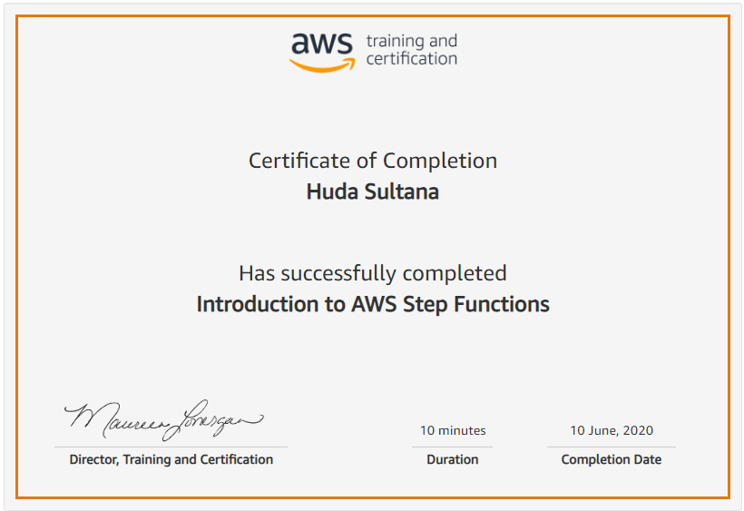

Coding Challenges Details: (Attach the snapshot and briefly write the report for the same)

**PROGRAM 1 .**

**//C program to print the boundary elements of the given matrix**

**#include <stdio.h>**

**int main()**

**{**

**int row,col,i,j,sum=0;**

**printf("Enter M (Rows) and N (Columns):\n");**

**scanf("%d%d",&row,&col);**

**int arr[row][col];**

**printf("Enter the Elements:\n");**

**for(i=0;i<row;i++)**

**{**

**for(j=0;j<col;j++)**

**{**

**scanf("%d",&arr[i][j]);**

**}**

**}**

**printf("The Input Matrix is:\n");**

**for(i=0;i<row;i++)**

**{**

**for(j=0;j<col;j++)**

**{**

**printf("%d ",arr[i][j]);**

**}**

**printf("\n");**

**}**

**printf("The Boundary Elements are: ");**

**for(i=0;i<row;i++)**

**{**

**for(j=0;j<col;j++)**

**{**

**if(i==0||i==row-1||j==0||j==col-1)**

**{**

**printf("%d ",arr[i][j]);**

**sum+=arr[i][j];**

**}**

**}**

**}**

**printf("\nThe Sum of Boundary elements of the Matrix is: %d",sum);**

**return 0;**

**}**